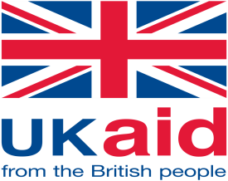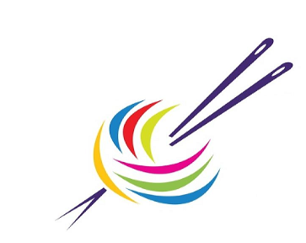

**Nepal Yarn Manufacturer’s Association**

**Consolidated Safeguard Policy for Yarn Partner Industries**

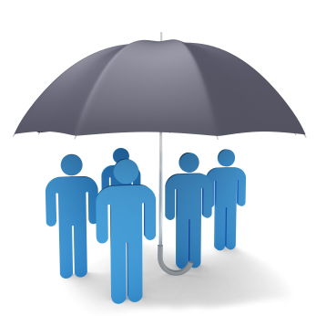

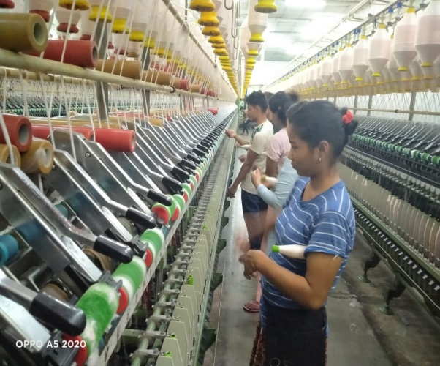

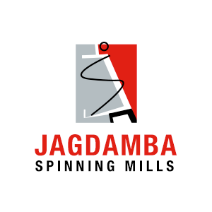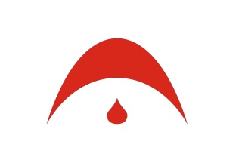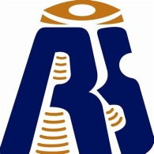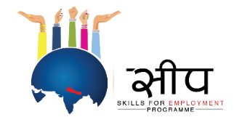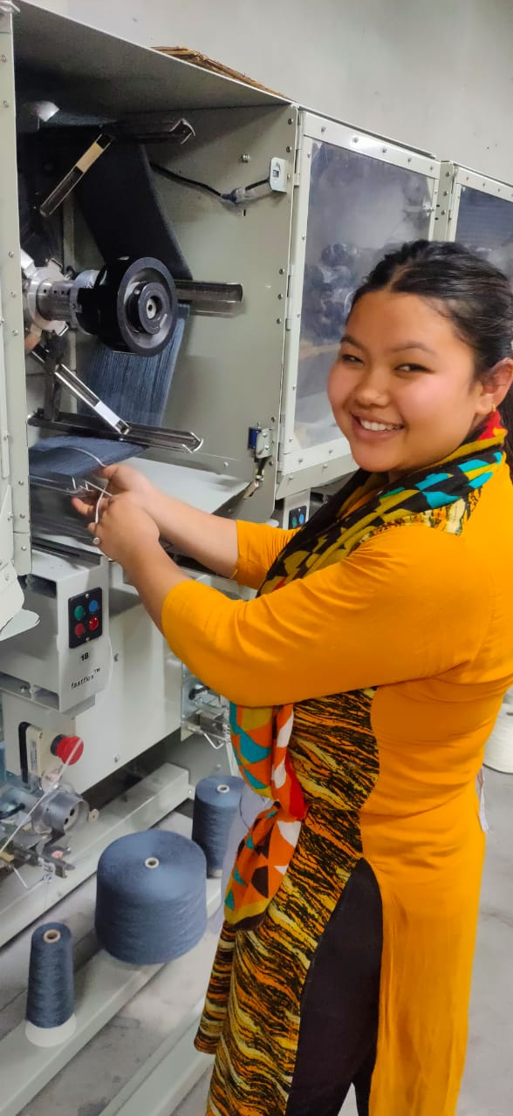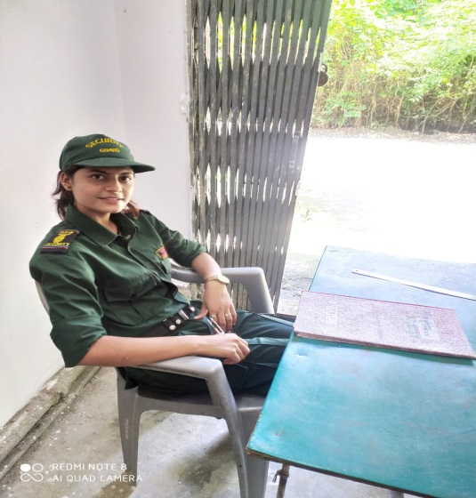

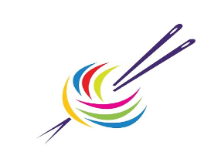

**NYMA’s Consolidated Safeguarding Policy for Partner Yarn Industries**

**Purpose**

NYMA’s consolidated safeguard policy statement describes common objectives of Nepal yarn manufacturers industries to safeguard all yarn industry workers. NYMA lays out common policy principles, and outlines the delivery process to safeguard all workers despite of caste, color, race, gender, creed, ethnicity, age, nationality and otherwise. This policy has been developed from common wider belief and corporate polices from all yarn partners of NYMA. It is common value among partner industries to preserve a right to protection from being hurt, and from violence, physical abuse, neglect, misconduct or discrimination of any form. The health, safety and welfare of all workers across all partners are of paramount importance to all the workers working in our setting. Workers deserve the right to protection, regardless of age, gender, race, culture, background or disability. This policy is in line Government of Nepal’s safeguarding policy and Nepal Labor Act 2074, local guidance and procedures.

**Definition**

***Beneficiary of Assistance***

Workers with partner industries that work within any department deserve rights to protection, goods and services. All workers and employees have a safeguarding policy in place.

***Child***

Person below the age of 18.

***Physical and Psychological Harm***

Medical, physical damage, in particular the one intentionally inflicted. Or, any form of psychological trauma or emotional damage that happens as a result of a distressing incident.

***Protection from Sexual Exploitation and Abuse (PSEA)***

Sexual assault is any sexual behavior that takes place without prior consent. Any form of sexual abuse, which involves, among other sexual acts, unwanted sexual contact, forced oral sex and rape, bad touch.

***Safeguarding***

The word safeguarding used in this document is to describe measures taken to avoid harm to protect workers’ rights. This damage can come from adults or any individual and it is vital that

****we understand what safeguarding is and why it is necessary as someone working closely with workers within factory. Safeguard policy is drawn from Labor Act policy 2074; therefore, it extends to all persons, irrespective of number for employers / staff.

Safeguarding means taking all reasonable measures to avoid harm, in particular sexual assault, violence and harassment, protecting people , especially vulnerable adults and children, from it and reacting appropriately when harm occurs.

***Working hours***

Working hours are only 8 hours a day, and 48 hours a day Week as provided for in section 28 of the Labor Act, 2074. The overtime salaries continue to be one and a half hours of his / her ordinary pay rate as provided for in Section 31 of the Labor Act, 2074. The maximum overtime increased to 24 hours a week, as per sec. 30 of the new act. Applied conditions as per company own HR policies.

***Sexual abuse***

Sexual abuse is any form of sexual violence, molestation, incest, including rape and the like. Sexual abuse is any type of physical or verbal molestation without any person’s will or consent.

***Sexual exploitation***

Sexual exploitation is an act or act committed through consensual abuse or misuse of the sexuality of another person for the purpose of sexual gratification, financial gain, personal profit or advantage, or some other unjustified reason. The sexual harassment acts or actions are forbidden unless the activity does not constitute one of the other crimes of sexual abuse. It occurs when an individual violates or exploits the sexuality of another without the consent of that person.

***Survivor***

The definition of a survivor is a person who copes with a bad circumstance or affliction and gets through or a person who continues to survive a circumstance.

***Adult at Risk***

An "Adult at Risk" is defined as any adult aged 18 years and over who is or may be in need of assistance due to mental health issues, cognitive or physical disability, sensory impairment, age or disease, and who is or may not be able to care for him or herself or protect him or herself from serious harm or abuse.

**NYMA’s definition of Safeguarding**

****NYMA defines safeguarding to “Protect any workers at risk of harm regardless of their age, race, gender, status, caste, religion can be with appropriate measure against harm or damage”.

**Scope**

Associated to all workers, trainers, supervisors, experts, managers, senior managers, finance and administrations, human resource, executives, beneficiaries, all staffs contracted by the three different yarn manufacturing factories along with Knitting industry I.e., Reliance Spinning Mills, Triveni Spinning Mills, Jagdamba Spinning Mills and Tricot knitting industry- Golyan group.

**Policy Statement**

NYMA consortium safeguarding policy ensures health, wellbeing and safety of all workers, staffs, trainers, executives, beneficiaries and in contact of consortium partners regardless of their gender, age, identity, physical disability, sexual orientation, and ethnicity. NYMA’s safeguarding policy ensures their right to protection to be protected from injury, violence, neglect and exploitation of every sort. NYMA does not allow employee violence and mistreatment.

The legislation would include the following areas of safeguarding, protecting children, protecting adults and protecting them from sexual harassment and violence. Such primary safeguard areas may have related to specific policies and procedures. NYMA safeguarding is largely consistent with 2074 Nepal Employment law. Also abides companies’ rules and regulation of four consortium partner industries. NYMA commits to safeguard throughout through providing protection, health safety and wellbeing.

**Ensuring health and Safety**

NYMA ensures to take action to remove or minimize any threat or risk where feasible danger to workplace safety or welfare, before resorting to personal defense appliances. Making arrangements to ensure, where feasible, the safety and the absence of risks to the health of manufacturing, processing, use, and handling.

**Responsibilities of employer**

All the industries shall abide, respect and align in terms of Labor Law of 2074 of subsection regarding safeguarding duties.

All the industries have the statutory responsibility and accountability for safeguarding and ensuring health and safety within their components and working environment.

Regulating programs, conducting trainings and manufacturing operations and activities in such a way to eliminate or mitigate, as far as practicable from potential hazards or any sort of misconduct of behavior.

****Follow up on safeguarding issues findings promptly.

**Child safeguarding**

NYMA consortium safeguarding policy is to ensure action and to promote children's welfare and protect them from harm.

***Safeguard means to:***

* Protecting children from maltreatment and violence.
* Preventing health or developmental harm to children.
* Ensuring that children grow up with safe and successful treatment.
* Committing to sexual activity with someone under the age of 18.
* Commit an infant to physical, emotional or psychological abstention or neglect.

**Adult Safeguarding**

NYMA consortium safeguarding policy is to ensure action and to promote adult safeguarding and protect them from harm.

* Commit a physical, emotional or psychological abstention or neglect.

**Reporting**

NYMA acknowledges and understands that whistleblowing is a difficult and challenging practice which can be a risky undertaking for an Employee without adequate protections? The Intention of this section is to:

Provide a framework for the reporting to a specified person of real or possible unethical behavior investigative jurisdiction, and appropriate action;

Cover all Workers reporting unethical activity under this section undue adverse consequences; and;

And protect who could be mistakenly or falsely convicted by successful enquiry procedures.

***Unethical behavior***

Includes any deliberate or accidental serious act or omission that contravenes companies policies, operating procedures, or the Code, illegal, unethical, immoral with serious or detrimental implications. Engaging in sexual activity anyone below age of 18, sexually, physically or emotionally exploiting. Any form of abuse or neglect. Implications on the public interest and the organization’s integrity.

**Security and Control**

****The Manager shall develop a framework for the security and access safeguarding in their particular industries and departments. Safeguarding and security facilities for every departmental workplace to ensure the safety of all employees and shall be executed by all Departmental offices.

**Violence in the workplace**

The employer shall, as far as reasonably practical, ensure that the workplace is violence free.

**NYMA’s consortium safeguarding policy:**

NYMA does not allow discrimination or revenge against someone who reports the suspected violence of statute, code and policies and procedures in good faith, even if the investigation does not consider any wrongdoing.

In addition, NYMA's policy-safeguarding consortium respects and abides by Nepal Labor Law Act 2074 along with own controlled policies of companies.

NYMA takes responsibility of tracking the safeguarding of information and complaints in accordance with policies and procedures as well as legal and legislative responsibilities.

**Confidentiality**

When dealing with security concerns, NYMA will ensure confidentiality is maintained at all stages of the process. Data relevant to the issue and subsequent case management should be communicated on a need to know only the basis and should also be kept safe.

**Associated Policies**

* Companies own controlled policies.
* Nepal Labor Act 2074